# ABSTRACT

* Python program to manually control an omnidirectional robot, using a python GUI
* The robot finds applications in: Industrial applications - single task robots. Pick and place, Military applications - autonomous unmanned vehicles.
* With the recent advancements in artificial intelligence and machine learning, there is a tremendous scope for robotics in the future.

# Objectives

To program raspberry pi Pico using micro-python.

To design and implement a GUI application using any popular python framework and establish communication between the robot and the application.

**Specifications of raspberry pi Pico:**

Raspberry Pi Pico is a low-cost, high-performance microcontroller board with flexible digital interfaces. Key features include:

* RP2040 microcontroller chip designed by Raspberry Pi in the United Kingdom
* Dual-core Arm Cortex M0+ processor, flexible clock running up to 133 MHz
* 264kB of SRAM, and 2MB of on-board flash memory
* USB 1.1 with device and host support
* Low-power sleep and dormant modes
* Drag-and-drop programming using mass storage over USB
* 26 × multi-function GPIO pins
* 2 × SPI, 2 × I2C, 2 × UART, 3 × 12-bit ADC, 16 × controllable PWM channels
* Accurate clock and timer on-chip
* Temperature sensor
* Accelerated floating-point libraries on-chip
* 8 × Programmable I/O (PIO) state machines for custom peripheral support

Pico provides minimal (yet flexible) external circuitry to support the RP2040 chip: flash (Winbond W25Q16JV), crystal, power supplies and decoupling, and USB connector. The majority of the RP2040 microcontroller pins are brought to the user IO pins on the left and right edge of the board. Four RP2040 IO are used for internal functions - driving an LED, onboard Switched Mode Power Supply (SMPS) power control and sensing the system voltages.

**Pin Diagram:**

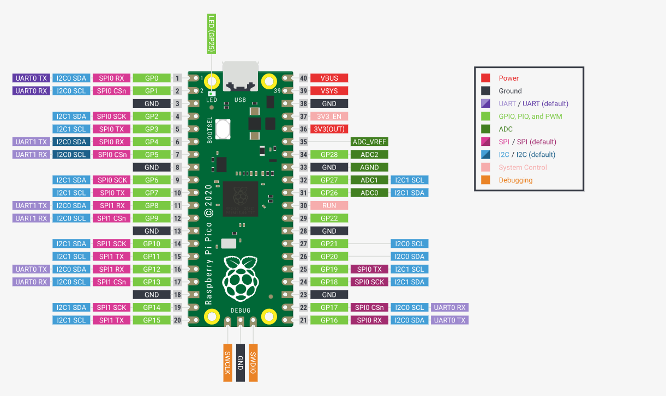

**Specifications of tb6612fng (**Driver IC for Dual DC motor)**:**

TB6612FNG is a driver IC for DC motor with output transistor in LD MOS structure with low ON-resistor. Two input signals, IN1 and IN2, can choose one of four modes such as CW, CCW, short brake, and stop mode.

**Features:**

• Power supply voltage: VM = 15 V(Max)

• Output current: IOUT = 1.2 A(ave)/3.2 A (peak)

• Output low ON resistor: 0.5Ω (upper + lower Typ. @ VM ≥ 5 V)

• Standby (Power save) system

• CW/CCW/short brake/stop function modes

• Built-in thermal shutdown circuit and low voltage detecting circuit

• Small faced package (SSOP24: 0.65 mm Lead pitch)

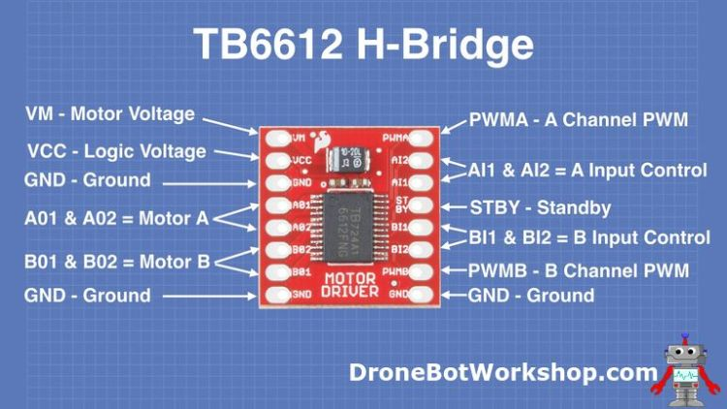

**Specifications of HM-10 Bluetooth module:**

The **HM-10** is a readily available **Bluetooth 4.0 module** used for establishing wireless data communication. The module is designed by using the Texas Instruments CC2540 or CC2541 **Bluetooth low energy** (BLE) System on Chip (SoC).

**Product Parameters:**

* BT Version: Bluetooth Specification V4.0 BLE
* Working frequency: 2.4GHz ISM band
* Modulation method: GFSK(Gaussian Frequency Shift Keying)
* RF Power: -23dbm, -6dbm, 0dbm, 6dbm
* Speed: Asynchronous: 2-6K Bytes Synchronous: 2-6K Bytes
* Security: Authentication and encryption
* Service: 0xFFE0 (Modifiable use AT+UUID command)
* Characteristic: 0xFFE1 (Modifiable use AT+UUID command)
* Characteristic: Notify and Write (Modifiable use AT+UU UID command)
* Power: +2.5V~3.3VDC 50mA
* Power: Active state 8.5mA; Sleep state 50~200uA
* Working temperature: –20 ~ +95 Centigrade
* Size: HM-10 27mm x 13mm x 2.2 mm

